**EXPERIMENT 8**

**Aim : (a)** To study a Test Management Tool **– QA Complete**

**Introduction**

Take the guess work out of the software delivery lifecycle. Provide your QA and development teams with the power to collaborate, track project progress, and report on requirements, test cases, and defects.

QA Complete allows you to take a strategic approach to testing by prioritizing key test functions, accounting for risk, planning for coverage, and controlling test execution. Employing effective test case management helps you ensure you’re running the right tests, and thus avoid releasing an application that is not customer-ready.

**Key Features**

**1. Test Case Management**

The ability to organize, plan, and analyse your testing efforts across the lifecycle is critical to your success or failure whether you use manual or automated test cases today. As projects cope with fewer development resources, higher quality expectations, and shorter development timelines, any serious development effort needs better test case management. QA Complete delivers:

* Manage manual test cases and link them back to the original requirements, thereby ensuring a requirement has been met. Evaluate the test run history of those automated tests right from QA Complete.
* Employ re-usable manual test libraries to quickly create new test scenarios.
* Graphically report automated test runs with plug-ins for many leading automated testing tools, including Test Complete and HP Quick Test Pro (QTP).
* Add, print, edit, or email test cases with a single click.

**2. Test Automation Tool Integration**

QA Complete supports many automated testing tools, including Automated QA Test Complete and HP Quick Test Pro. Integration with test automation tools allows you review the run history of any automated test on any machine, so if you have a test lab with multiple machines running automated tests, you can compare machine run history. Since you can co-ordinate both manual and automated tests, you have better test information to make release decisions.

By integrating automated testing into QA Complete, you can:

* Launch the tests from within your automated tool and automatically report the run information to QA Complete for analysis of runs over time.
* Trend results using graphical dashboards and schedule tests to run unattended.

**3. Bi-Directional Traceability**

The goal of traceability is to ensure “adequate” test coverage for each software requirement. It is important to maintain traceability both forwards and backwards, from requirement to test case and from test case to requirement. This ensures that design specifications are appropriately verified and that requirements are appropriately validated, ultimately reducing software defects and – this is the ultimate goal, after all – improving code quality.

* Link together requirements, test cases, and reported defects.
* Drag and drop functionality to link test cases or defects to a requirement.
* With one click, see a traceability report showing all linkages to a particular requirement.

**4. Requirements Management**

QA Complete helps you manage requirements regardless of your team’s development methodology. It lets you define requirements for each release and track the release for which each requirement is scheduled. Govern workflow and state transitions. Using workflow, you can force design reviews, approvals, or test reviews.

* Easily set rules for status transitions.
* Automatically assign tasks to team members based on requirement status; receive email alerts when requirements change.
* Attach documents to any requirement (such as detail designs, specifications, and prototypes), and track versions of those documents.
* Add notes to the requirement, allowing the team to discuss requirement changes and other important issues.
* View an audit history of any requirement, showing who made a change, the date and time of the change, and the before-and-after values.
* Rely on an extensive set of standard and ad-hoc dashboards and reports (requirements missing test cases, etc.).

**5. Defect and Issue Tracking**

QA Complete allows you to track status and resolution progress of defects and issues for each release. Instead of spending your time entering data, the software automatically generates a defect identifier on failed test cases.

Integration with Atlassian JIRA, Bugzilla, and other web-based defect tracking tools allow you to blend QA Complete features with the defect tracking tools your organization already uses.

* Coordinate QA and development teams to coordinate activities as bugs are found. QA Complete has a full featured defect tracking component.
* If your team already owns a bug tracking system (like JIRA, Bugzilla, Microsoft TFS, etc.), you can create defects inside of QA Complete and have those automatically synchronized with your bug tracking system.
* Source code integration lets you associate source code with fixed defects. By doing this, you can quickly discover which code modules are the buggiest, allowing your team to put effort into raising the quality of that code.
* Defect reports and dashboards show defects by severity, priority, or other criteria.

**6. Seamless Integration with other ALM Tools**

If your team has already sunk costs into an existing requirements or defect management tools, it may be difficult to convince your team to switch. With QA Complete, you don’t have to switch. QA Complete can seamlessly integrate with many defects and ALM tools including Microsoft Team Foundation Server (TFS), HP Quality Centre, IBM Rational Doors, IBM Rational Requisite Pro, Rational Team Concert, Atlassian JIRA, Rally, Version One, Bugzilla, and Accept 360.

**7. Seamless Integration with Source Control Systems**

Associating defects and requirements with source code provides great traceability, allowing you to quickly discover troublesome code and requirements that required the most re-work. Using the QA Complete SCM integrators, you can associate defects or requirements when checking in source code.

**8. Extensive Dashboards and Reporting for QA Activities**

QA Complete provides an array of analysis tools. Status screens, dashboards, and reports help you stay on track, better plan your next release, and answer the most pressing questions about your software development projects. For example:

* Are you progressing properly in your test cycle? The Test Case Trending dashboard shows how many test cases are still awaiting run, how many passed, and how many have failed, day-by-day.
* Which tester has the most assigned defects? View a Defect Assignee report that shows defects by assignee. Click the assignee graph to get further details, print, export to Word, Excel or PDF, or email the results.
* Review team and project variances, allowing you to you learn from each project as to improve future estimates.

**9. Easy Data Entry**

QA Complete makes it easy for you to automatically generate a defect from a failed test case. With one-click cloning of records, you can pass along to your development team all the relevant steps to reproduce the problem, along with expected and actual results, without having to re-enter anything.

* Automatically create a link between the defect and the test case.
* Existing test cases linked to a requirement automatically link the defect to the requirement as well for full traceability.

**10. Flexible Licensing Model**

Our QA Complete SaaS offering allows you to focus on your core business activities while keeping costs down. Our online option means you don’t have to mess with server configuration, hardware support, or other data centre annoyances. Sign up to get up and running immediately and leave the hosting to us.

* On-demand, available anytime, from anywhere.
* Sign up and turn it on with no implementation effort.
* Safe and secure Data Centre.
* For those who would prefer to host the software, or are unable to use a SaaS model, we also offer an on-premise option. Both are backed by our outstanding and friendly support staff.

**11. Web Based User Interface**

QA Complete has a Web interface. Nothing needs to be installed on your hard drive.

* Users with an Internet connection may access QA Complete from home or anywhere in the world.
* Distributed and offshore teams can easily share QA artifacts with one another and local teams.
* Supports all major browsers, including Internet Explorer, Fire Fox, Safari, and Google Chrome.

**Aim : (b)** Automate the Test Cases using Test Automation Tool **– QA Complete**

**Introduction**

QA Complete is a test management tool that can be used for both manual and automated testing. It is a tool with powerful test management capabilities that allow us to track all aspects of software quality in an efficient manner. QA Complete supports all aspects of test process and ensures the delivery of high-quality software.

**Benefits**

1. QA Complete can be integrated with any number of tools
2. Customizable as per the tester’s needs
3. Requirements and tests can be traced to defect effectively
4. Reports and dashboards are the key features of QA Complete

**Features**

1. Test case management – simple test case structuring also allows for focused metrics and clear status report
2. Test environment management – various environments are linked to individual test cases for effective test coverage across different platforms, operating systems, and devices
3. Defect and issue management – mainly tracks the resolution process of bugs for each release and automatically creates bugs when test cases fail
4. Test automation integration – can be integrated with various automation tools, and it allows us to track and report overall (manual and automated) test management efforts at a single place
5. Bug tracker integration – can be integrated with various bug tracking tools
6. Shared documents – stores all test documents in one central location to improve collaboration

**Steps to Setup and Work on QA Complete**

To manage and produce the right test deliverables, let us assume an e-work sight login page needs to be tested manually. The following steps and screenshots will explain how we can manage the test deliverables using QA Complete test management tool.

***Step 1:*** Log into QA Complete Tool

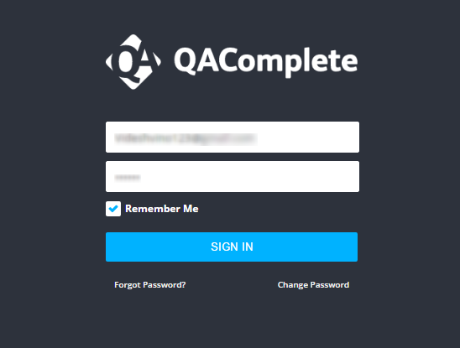

***Step 2:*** Create a new release as e-work under the release tab by clicking the add new icon and click the add new item to add an iteration/build.

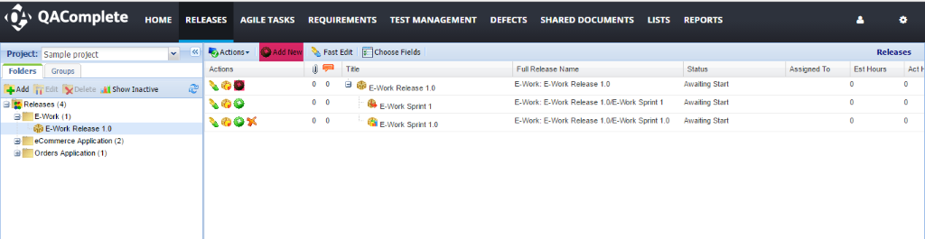

***Step 3:*** Navigate to the test management tab -> test library -> add new folder.

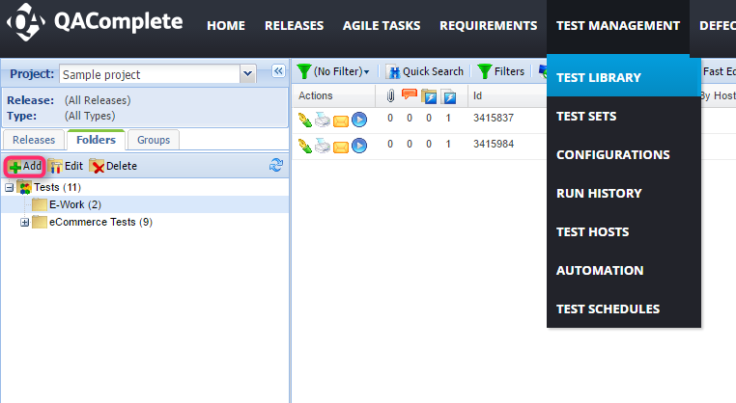

***Step 4:*** Navigate to test management tab -> test sets -> create a folder (add the ‘+’ @ left panel) -> create a new test set using the add new icon -> after entering the details click the submit button -> navigate to the tests tab and design the steps accordingly.

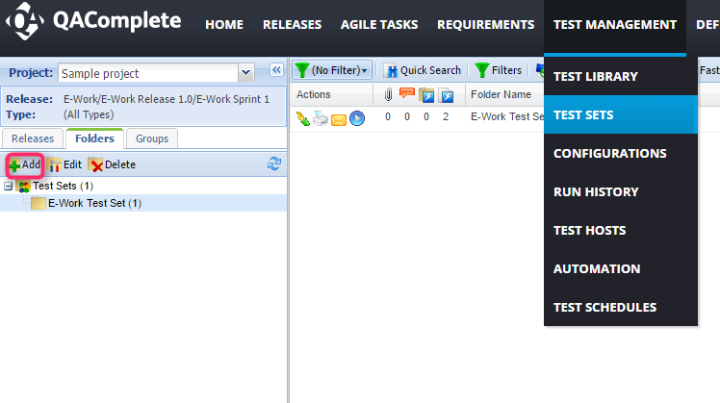

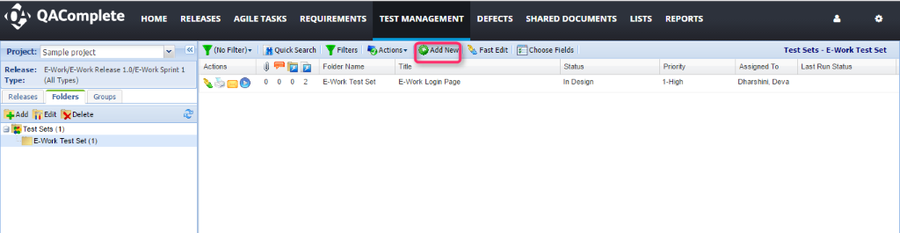

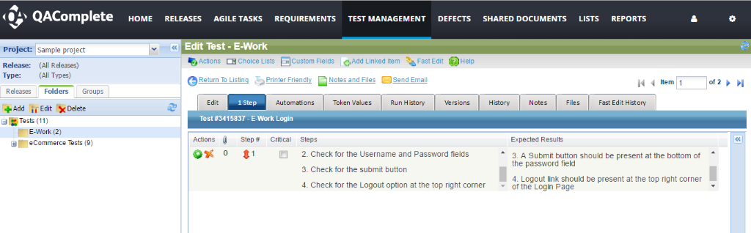

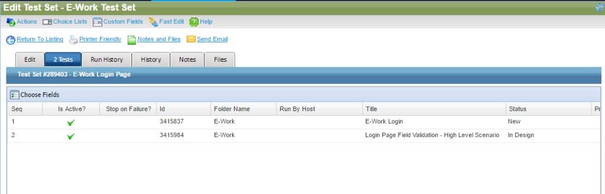

***Step 5:*** To run the test sets -> test management tool -> test sets -> click the run icon.

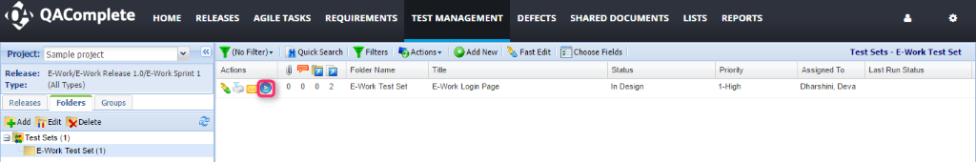

***Step 6:*** Click the start run at the top right corner. Based on the working functionality, select the run status and click the End-Run option finally.

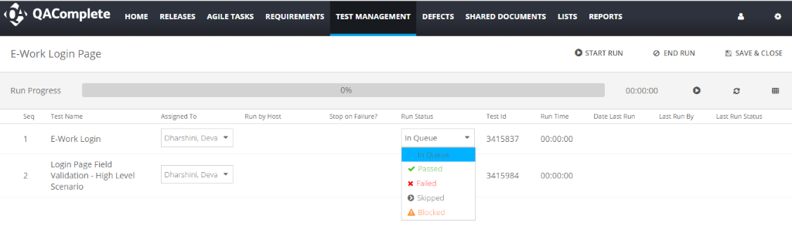

***Step 7:*** If any of the steps fail in a test set during the run, it prompts to create a defect automatically.

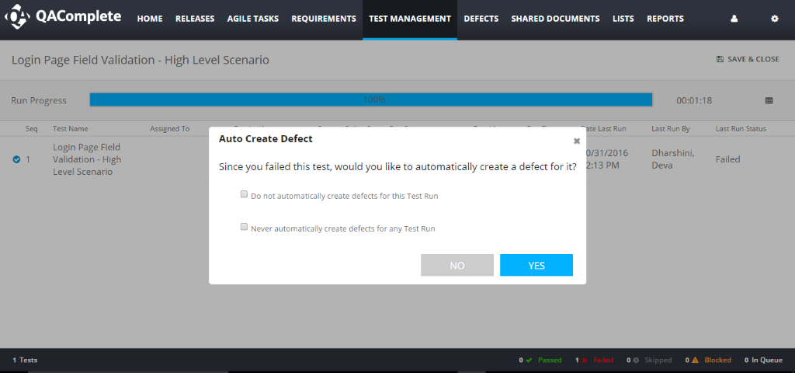

***Step 8:*** When the yes option is selected, a defect is created automatically.

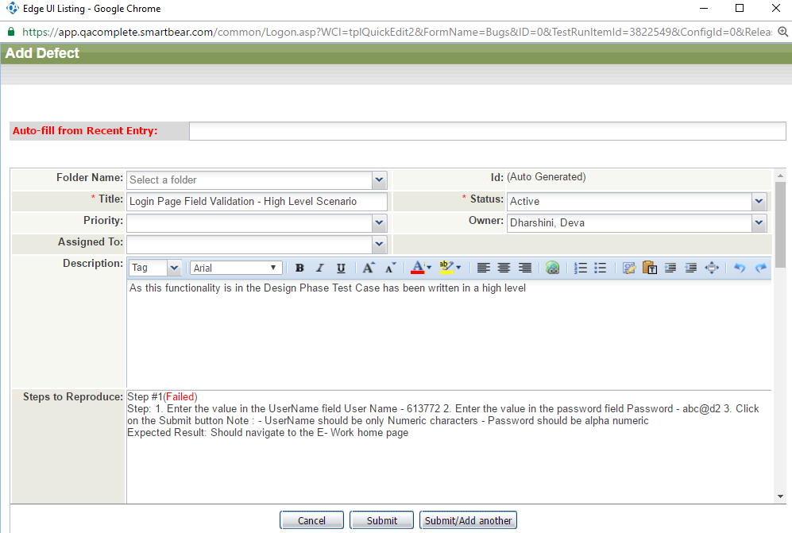

***Step 9:*** Navigate to the defects tab and view the automatically created bug(s).

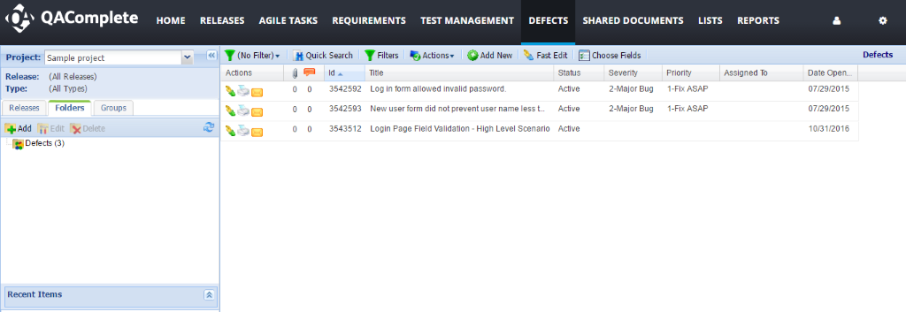

**Synchronize the QA Complete with JIRA Project Management Tool**

To synchronize the QA complete test management tool with the JIRA project management tool we must install and configure QA Complete – JIRA Connector.

**QA Complete - JIRA Connector**

It is a connector to synchronize JIRA issues with QA Complete defects or requirements.it synchronizes the data based on the settings that are done i.e., Unidirectional synchronization/bidirectional synchronization.

* **Bidirectional –** any change made in one system will be updated in the other system
* **Unidirectional –** changes that are made in the source system will be updated in the destination system (changes made in the destination system will be overwritten by the changes made later in the source system).

**Advantages**

1. Defects are created automatically under the defects section as a test step fails in a test set.
2. Automation tests can be scheduled accordingly for the next run.
3. Synchronization with tools like JIRA helps in providing the deliverables in the right way.

**Conclusion**

QA Complete test management tool might be of great use to the QA team in producing effective deliverables at the right time.